Board of Directors Meeting
Sechelt Arena
Thursday Feb 8, 2023 6:30 pm

Attendance: Kate Turner, Adam Gibson, Kori Hudrick, Kendra Bell, Melissa Kelly, Melissa Tripp, Karen Graves, Christine Hardt, Jenise Powers, Poppy Hallam

Regrets: Adora McTaggart

Call to order: 6:36

Special Presentation: Rick Hopper re: SCMHA & Tsunami Junior Hockey Impact and Opportunity

Motion to Approve previous minutes: Kendra Bell

Approval of agenda: Jenise Powers

Business arising from previous minutes/action items: Reports sent in ahead of time so that board members can review and then have questions ready to help speed up the meetings.
All tasks from previous meeting were discussed and all completed.

President’s Report:

- PCAHA Bulletins that have been distributed to the Association.
  - Bulletin #8 – U9 transition to full ice
  - Bulletin #9 – Attending Tournaments during playoffs.
  - Bulletin #10 - Game Protest Procedure during playoffs.
  - Bullet in#11 – Sportsmanship Point in Playoffs.
  - Bulletin #12 – April 1st Resolution Deadline.
  - Bulletin #13 – Special Awards.
  - Bulletin #14 – Application of time out rule.
  - Bulletin #15 – Final 4 Assignments.
  - Memo – Shortened 3rd Period in PCAHA playoffs.
  - Tiebreaker rule

- PCAHA has distributed the playoff formats for U11A-U18A, as well as
the Rep Playoff Guidelines U13 – U21.

Moving forward, I will add PCAHA Bulletins to our Google drive. I do distribute Bulletins to appropriate teams-coaches-managers. Should we add them to website???

PCAHA Semi Annual General Meeting was on Jan 28th. Items discussed.
- Financials
- Budget
- U11 Pathway – Task force continues to work on. Looking for additional input.
- Looking to start a U13/U15 Pathway Committee.
- Abuse and Harassment Committee – Continue to have a lot of issues with behaviour.
- Scholarship Showcase games
- Scholarship Program – Deadline March 31st – Note went out to U18 teams.

Lions Gate Feb Board Meeting
- Jim Fryer Memorial Tournament went off well. We had 2 players take part.
  - Hannah Wing
  - Rylee Vourtsis

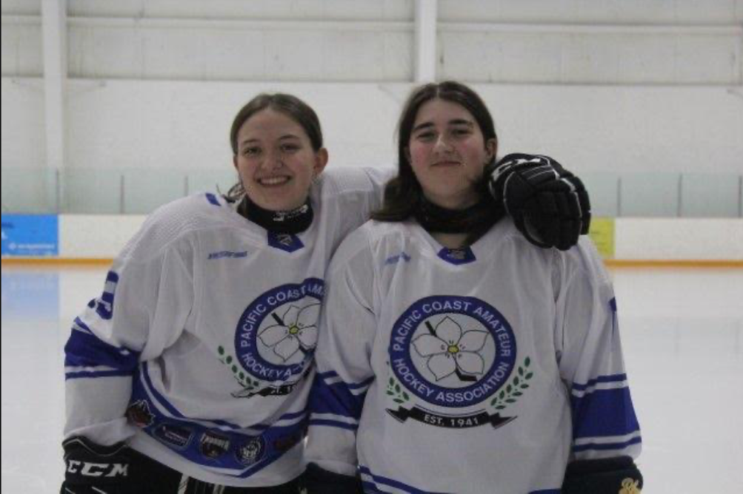

- We couldn’t secure funding sponsorship from Rona for the Jim Fryer Memorial tournament jerseys. Payment will be the responsibility of the 7 associations. Voted to have this payment divided over 3 seasons verses 2. Passed
- Playoff Structure – talked about updating the wording in our official guidelines to allow more flexibility in how many groups we run each year. Wording changes will be tabled until August 2024 meeting and if passed will be available for next season.
- Banners – All banners have arrived. Team achievement winners have been chosen and approved.
- Score keeping continues to be an issue. PCAHA will be providing an online course /tutorial which all volunteers will have to take prior to scorekeeping.
- Playoffs start Feb 9th and to be wrapped up by March 8th.

Around Association

- Continue to have issues with flex room. It must be understood that this is a shared space. Key is to be signed out. This space is for privacy while changing. It is not to be a hangout for friends.
- Referee issues experienced by both 18C teams while off coast. Concerns that refs have bias against the Coast. Inappropriate behaviour displayed and noted. Our RIC, Aspen Wing, has notified Owen Barry, Lower Mainland Officiating Coordinator. Owen’s response was he’ll be reaching out to the Zone 5 referee assigner and will be discussing professionalism on the ice.

IN-CAMERA 7:43 pm. Complaint regarding refereeing off coast.

CONTINUED IN-CAMERA: Adam and Kate managing and monitoring two players with suspensions and or high penalty minutes.
OUT OF CAMERA: 7:48 pm.

Vice President’s report:

IN-CAMERA: 7:49 pm
Coach complaints.
OUT OF CAMERA: 7:53 pm

Graham of SCRD sent an email about use of the rink and how we are representing and noise complaints with warmups outside with boom boxes and inappropriate language.

Registrar:

Current registration sitting at 273. We had a decent turn out from First Shift. 6 new players between U9 Minor and U7. I did have a few more request info, but did not complete registration paperwork. Also had one send in paperwork, but would require an IIHF transfer as the player was born in the US and would not be completed in time to make the roster cut off (which is Saturday February 10th). Working on another hockey access request.

First shift used to be registered though minor hockey, but they no longer are.

Ways and Means:

The U9 Tournament was a great success, with many volunteers and excitement.
Was in the early days of full ice for the teams so lots of communication with the refs and lots of learning.
** Need more comprehensive set of rules

U13A is six teams, and planning is going well

Raffle tickets will be drawn next weekend.

Moms night out led by Kori planning underway

I sent out Ways and Means update email last week

More and more managers are sending info for social media - great to see

Riptide dates were released, and I have started to collect sponsorships.
Nine confirmed so far, ten more to sell

The schedule for Riptide is reserved for the spring, and we have room for:

First Riptide
April 4,5,6 & 12, 13, 14th
4 U9 / U11
4 U13
5 High school
Second Riptide
April 19, 20 & 21
3 Timbits
Three female
Nineteen total teams - 190 kids.
The main concern will be having enough goalies for so many teams!
These dates do not conflict with anything planned for Spring Hockey teams or skills sessions via Tsumani's

Sponsorship $225 ~ Companies get their name on the backs of the jerseys
Entry fee: $125
Take-home item - TBA! Any ideas I'd love to hear?
Last year, we did a poll to see how many players would sign up, but it is likely not needed this year; it's created a bit of confusion as people thought they were registered.

Jersey Purchase for Riptide - I got three quotes that range from $4000 - $6000, with an off-coast company coming in considerably cheaper.

** If we do not get this many teams, we will still be responsible for this ice, so create a bit of a contingency plan there

50th Anniversary Celebration first meeting - Feb 19th 2024
- Events
- First Nations inspired third jersey
- Collection of memorabilia over the years to include in historical installation in the arena

Upcoming:
Awards and celebration evening usually is the first week of April, but that is TBA! I don't see any need for format change right now, it is well received.
Start to check in with people about their volunteer fee reimbursement

Treasurer:
Account Balance: $260, 895.04

2023 - 2024 Hockey Season
 | Income Statement May 31 2023 | Budget 2023 - 2024 | Variance
Player Registration | $ 216,853 | $ 173,566 | $ 43,287
Rep Player Add't Fees | 17,254 | 38,375 | -$ 21,121
Total Registration Fees | 234,107 | 211,941 | 22,166
Fundraising | 8,636 | 12,500 | - 3,864
Gaming/Via Sport Grants | 40,000 | 40,000 | -
Interest |  |  | -
Player development |  |  | -
Hardship allowance |  | - 6,000 | 6,000
Sponsorship | 6,905 | 12,000 | - 5,095
Spring hockey Programs | 276 | 23,000 | - 22,724
Summer hockey Programs |  | 35,000 | - 35,000
Tournaments | 44,913 | 35,000 | 9,913
Third Jerseys | 6,994
Volunteer Fees |  | 18,720 | - 18,720
Total Revenue | 341,832 | 382,161 | - 47,324
Awards & trophy costs |  | 3,750 | - 3,750
Bank charges | 191 | 10,500 | - 10,309
Bursaries |  | 1,000 | - 1,000
Coach travel reimbursement | 2,631 | 8,500 | - 5,869
Coaching fees (non-parent) | 12,000 | 14,000 | - 2,000
Dues - Teamsnap | 1,733 | 4,000 | - 2,267
Director of Hockey fees |  | 12,000 | - 12,000
Ice rental | 72,672 | 160,000 | - 87,328
Insurance - BC Hockey/PCAHA | 6,978 | 23,500 | - 16,522
Office supplies | 50 | 1,200 | - 1,150
Player development costs | 4,218 | 10,000 | - 5,783
Professional fees |  | 1,000 | - 1,000
Promotion | 756 | 2,000 | - 1,244
Referee costs & training | 24,113 | 25,000 | - 887
Spring hockey costs | 3,260 | 9,550 | - 6,291
Summer camp costs |  | 35,000 | - 35,000
Supplies, equipment & jerseys | 26,656 | 37,500 | - 10,844
Team share | - 295 | 4,000 | - 4,295
Tournament costs | 21,187 | 20,000 | 1,187
Tournament travel - provincials |  | 2,000 | - 2,000
Training | 1,759 | 2,500 | - 741
Travel AGM |  | 1,500 | - 1,500
Year-end ceremony |  | 5,500 | - 5,500
Third Jerseys
Hockey Access Fund | 1,898
First Shift | 600 | - | 600
Total Expenses | 177,908 | 394,000 | - 216,092
Net income (loss) | $ 163,924 | -$ 11,839 | $ 168,768

Secretary:
Nothing to report

Director of Female Hockey:

Play offs begin this week.
U13 female played a game at Rogers arena last Sunday. Team was treated with a tour of the arena and dressing rooms before heading on the ice to play a full game. Highlights and jumbotron interviews included.
Spring break try me camp went out just over a week ago now. Working with U9 parents to help spread the word in the elementary schools.
Currently we have 17 girls signed up already.
Our goal is to have U9,U11,U15,U18 female teams next year.
Will need to make sure we have our female camp ice week available in the summer to continue with the growth of female hockey.

New business
Attended the female committee meeting Jan 15
We were asked to get feedback from our board about U7/U9 major/minor program. Currently the female program does not follow this and is looking for feedback before applying it to the female league.
Some complaints about it U9 minor and major and issues with so many kids . Adam spoke with Mike Hobbs and Adam Nanson about local jamboree scrimmages between the two teams if they are sharing ice. They can mix up the teams so the teams are balanced.

Ice Scheduler

Playoff schedules dropped, now in full swing of resolving all the conflict games.

Chatted with Nicole regarding the core schedule for next season. Have a rough schedule drafted up, just need to make a couple tweaks before I send it to Tom. We need the SCRD to drop the public skate at SCA on Saturdays so we can make all the games fit on weekends. Trying not to upset other user groups a ton, we've had to add two ice times during the week, in the rough draft we've allotted for one extra team next season.

Equipment Manager

- slip skill tech: fast mag pros training tools were ordered and should be here any day. They are $4200 not $4000
- missing jerseys have arrived
- pant shells have arrived and were a different wrong colour, attempting a third time and will continue to contact the company frequently for updates
- starting to look into different options for a third jersey supplier
- next month… preparing for next season, checking inventory of shells and gloves. Supply may be sufficient for next season; if not, will be looking into a different supplier.

6:38 continue the meeting

Director of Recreation and Initiation:

- Completed end of regular season check ins with each house team to answer questions/concerns regarding the season, playoffs and next season.
  - Wednesday Jan 31 attended joint U18 C1 / C2 practice
  - Friday Feb 2 attended joint U11 C1 / C2 practice and U13 C practice
  - Saturday Feb 3 attended U9 Major game and U15C1 game
  - Sunday Feb 4 attended U7 practice and U9 joint Minor/Major practice
- Most questions came from U7, U9 and U11, with some great ideas that I am following up on regarding information sessions for families changing divisions. Concerns/questions were raised re a number of topics, including the following discussion items for the board:
  - AP Requests for C teams - Why does U11 have to follow a different practice than U13, U15 and U17? Because the U11s are APing kids from U9 who are not in a league. It’s a PCAHA process and perhaps we can speak with them for next year.
  - Year End Meetings - proposal to have year end wrap up meetings with each division prior to AGM. Especially with U9 moving up to U11 and rep tryouts.
  - Volunteer Hours for Families joining mid season - can they be pro-rated? It is hard to for a family to put in 10 hours when there is only 1 tournament left. They do not pay a volunteer fee so they don’t have to do the 10 hours of volunteering.
  - First Shift and late season rostering process: Concerns were raised regarding the large influx of players late in the season to U9 minor, with no increases to the U9 major team. Discussed this with both coaches and how they can adopt to the roster size and have at home jamboree scrimmages between teams.
  - U9 Pathway: parent concerns regarding the major / minor program
  - Late games / last ferries - is it possible to impose a limit for each age group?
  - U15 Practice Times - original discussion was that we would swap them to earlier time mid-season, can we make this happen?
- Invoices for the play off referee fees were submitted and have been paid out to all C and Female teams. Each team is required to finalize their ref fee statements by the end of their season and submit them to me. I will reconcile them and provide them to Karen with details as to which teams owe us money.

Risk Manager:

Criminal Records: There are people who have started the process, didn’t finish the record check by getting fingerprinting, and are not on the HCR and have not completed the criminal check process. At this point, they are not people who are volunteering or on the bench, so it’s a non-issue.

The two-deep rule in change rooms. This is coming up in the risk management chatroom and whether we have two people in change rooms with criminal record checks.

*** Summer meeting: discussing how we want to go forward with change rooms and our association rules. We can also have our parents take the respect in sport. But then we cannot enforce it. Prop the door up.

Ordered some more equipment

New Business:

Christine Hardt: End of year talks to the teams to answer U7, 9, 11, 13.

Melissa Kelly
18A is fine
U15C is fine, except Ryan
U15A were using it after Christmas
U13C and A (shared their jersey after Christmas)
U18C was not able to share their jersey and they only received their jersey last week.
U18C1 Kori - borrowed one from an injured player and one game from a U13. They just wore them this weekend and started .
Christine: Reimbursement for the team - ½ and the person who didn’t get theirs 100%.
Is there a difference between

7 jerseys to be reimbursed at 100%
The younger teams had a chance to wear their jerseys more than the U18C1 team.
Jerseys are $105 per jersey.

Motion to reimburse:
$50 each toward the U18C1 team (13)
$25 to the U13C (19)
$25 to the U15A (17)
Reimburse the 5 players for $105 that did not come on time
U13A spare jersey

Money will go back to the team manager at $25, $50, $105 per player. Melissa Kelly will look at who has paid for their jerseys and to those who haven’t paid, then credit the $25 or $105 to their Teamsnap account. Those who have paid, Melissa Kelly will send that information to Karen, who will then give the money to the team manager to disperse.
Estimated cost is about $2200

Melissa Kelly will update with the outcome of discussions with the company and report back. The membership will know that

In camera 7:35 pm.
One of our assistant coaches was hanging out with younger players on off time and in a hotel room where the assistant coach may have supplied liquor. Kate put together a letter to the parent however it has been decided by the board that Kate and Adam will sit down with the assistant coach.
8:12 hrs out of camera

*Risk management and code of conduct.

Send out emails on behalf of the board.
When sending out emails sharing information for other associations, for-profit or non-for-profit, we need to include a disclaimer that shows that we are sharing on behalf of the other association.

Questions:
Justin Towell asked If there was to be two 11A teams?

Is there a question of the week we could put out on social media. Link things to the website.

To Do:
Adam: speak to Credit Union about fees
Karen: The square debit/credit scanner standalone is about $400. Just want to look at the budget before spending anymore. Tabled for July summer meeting for next season

Rep tryouts: to have tryouts to occur earlier in the season so it doesn’t drag out for the house teams.

Agenda item add: There are lots of parents with questions about minor hockey in general that some board members cannot answer. Idea is to have questions from parents/teams for the board.

Did not get through meeting items so need to continue with another meeting next week.

For next meeting:
DOHO:
Meet in March and have a working session
Send out the previous job description for the DOHO ahead of time
March 12, 2024 Gibsons 6:30 - 8:30 pm
Next meeting –

